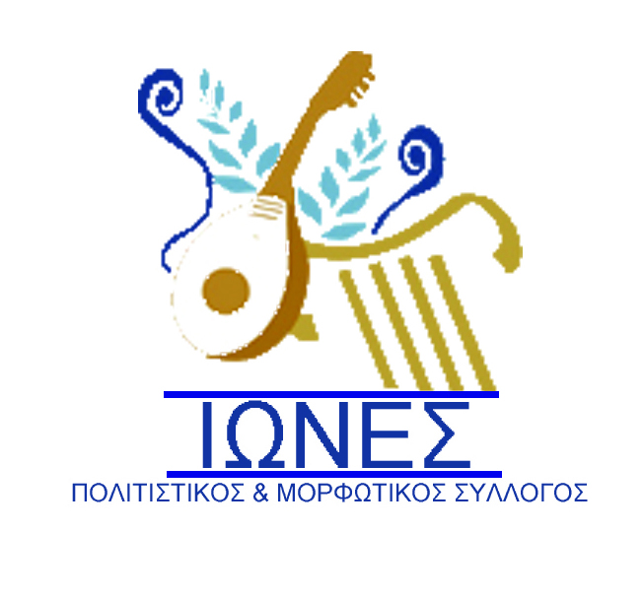

CULTURAL AND EDUCATIONAL
ASSOCIATION ΄΄IONES΄΄
www.iones-eliki.gr e-mail:info@iones-eliki.gr
e-mail:asimakis.iones@gmail.com
Information:Asimakis Stavropoulos

Mob:00 306948115031- 00306908542376

19a ¨΄POSEIDONIA 2025

19th WORLD FESTIVALS TRADITIONAL DANCES
3/7-7/7/2025(5 days)
APPLICATION FORM
Contact information
Name of the group :
Adress :

E-mail :

Website :-------------------------------------------------------
Telephone
Fax
Director of Arts:
Leader of Group:
Participants’ Information
Number of participants:
Male Female Total
------------------------------------------------------------------------------Dancers/performers:
Musicians/singers:
Male Female Total
Directors/Leaders:
Others
Average Age:
Other Information
Other information-questions you need and would like to ask:
Technical information
Live Yes or No:
Microphones needed (Voice):
Microphones needed(instruments):
Special Props or stage Elements
Signature
………………………………………………………
Date and Stamp:

